Course Start

Course Start is independent learning you need to complete as a fundamental part of your introduction to the course. It should take you approximately 5 hours to complete.

| Course Name | **IB History SL and HL** |
| --- | --- |
| How this Course Start fits into the first term of the course | This induction will begin to look at the nature of history. What do we mean by history? What is the role of a historian?  We will begin to consider some of the depth studies which will be relevant later in the course, such as China, giving you a better understanding of the period.  In addition we will consider the nature of revolutions throughout history and their consequences.  Finally we will consider the idea of interpretations, where do historians’ views come from, and why do they differ? |
| How will my Course Start learning be used in lessons? | This will be linked directly to your first week of teaching, and referred back to as we begin China and your coursework. |
| Course Start learning objectives | * Understanding key concepts in History e.g. causes, consequence, turning points, significance, change & continuity, interpretations * Understanding chronology & significance of events for one of your Y1 Papers * Developing appropriate study skills for IB History |
| Study Skills | * Independent research * Conceptual thinking * Developing your own ideas & opinions |

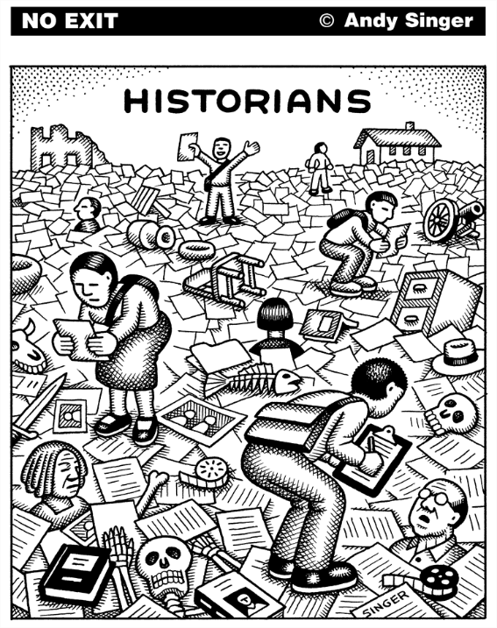

Hello! Welcome to Varndean College History Department – we are history obsessives & have put together a course that we think you will find rewarding, engaging, challenging, maybe even inspiring.

To help you feel confident and ready for IB History, we’ve put together some activities to introduce you to key concepts from the course including causation and impact; change and continuity; historians’ perspectives. We hope that these will also help you to reflect on the nature of History as an academic discipline, and patterns that we can observe in events that happened in vastly different times and places.

1. **What is History?**
2. **Talking about a revolution**
3. **Case study: twentieth-century China**

We suggest that you do these tasks in 2 or 3 sessions over the summer - don’t try and do them all in one go! You **must** work through all 3 tasks (and you **should** do all of the questions in each section):

You **could** also delve deeper into the past by following up some of the suggested links or dipping into anything that catches your eye from the reading list.

We’ve included some course details and FAQ at the end of this document, but If you have any other questions or concerns, feel free to email me.

**Ruth Kelly (Programme Leader, History)**

[rak@varndean.ac.](mailto:rak@varndean.ac.uk)

1. **What is History? (Must do)**

* **What is the difference between “history” and “the past”?**
* **In what ways have the sorts of topics studied by historians changed over time? Give examples.**
* **How does studying the experiences of diverse groups of people give us a more detailed understanding of British history?**

**2. Talking About A Revolution (Must do)** 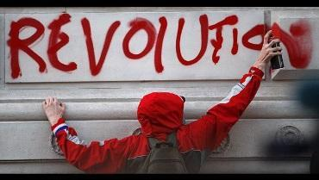

On the IB History course you’ll be comparing historical developments in different regions of the world, including China, Argentina, Russia, USA, South Africa and western Europe.

One theme common to all of the regions that we study is that of [**revolution**](https://dictionary.cambridge.org/dictionary/english/revolution)**.**

**i) Define REVOLUTION in a sentence, or create a spider diagram showing its meaning.**

**ii) Let’s look at some historical examples of revolutions.** For each example, watch the short clip and note relevant details in the table below. You can make your own copy if you prefer. ( You might have a couple of gaps - that’s OK)!

| **Location** | **Event & dates** | **Causes?** | **Impact?** | **Who was involved (groups or individuals)?** |
| --- | --- | --- | --- | --- |
| [**England**](https://www.youtube.com/watch?v=WsML7hiTnsY) |  |  |  |  |
| [**Britain**](https://www.youtube.com/watch?v=pIJSisZ23p4) |  |  |  |  |
| [**France**](https://www.youtube.com/watch?v=PBn7iWzrKoI) |  |  |  |  |
| [**Russia**](https://www.youtube.com/watch?v=KOK1TMSyKcM) |  |  |  |  |
| [**China**](https://youtube.com/watch?v=GAGgXz_N98U&t=23s) |  |  |  |  |
| [**India**](https://www.youtube.com/watch?v=-sw19FyG2oY) |  |  |  |  |

iii) **Historians love to look for patterns.**  What **similarities** or **differences** can you identify in the causes, impacts or groups of people involved in the revolutions that you’ve learned about?

iv) **Historians enjoy putting forward new perspectives on a topic, and debating these.** What examples can you find above of historians saying that they disagree with the way that an event has previously been interpreted? (For example look again at [Julia Barker’s comments on the Great Revolt of 1381](https://www.theguardian.com/books/2014/dec/30/england-arise-juliet-barker-book-review), or [Helen Rapport’s view of the 1917 Russian Revolutions](https://www.theguardian.com/books/2016/nov/23/caught-in-the-revolution-review-helen-rappaport-russia)).

iv) **Choose one of the revolutions above (or a different one of your own choice), and write a couple of paragraphs (up to 500 words) explaining why, in your view, it was historically significant.**

*You could consider criteria like - did it result in immense change? Did its impact last a long time - perhaps it still influences events today? Did it affect a wide geographical area or a large number of people? Was it an event that attracted a lot of interest or attention, either at the time or since?*

**Could do: What makes for a successful revolution? (30 minutes)**

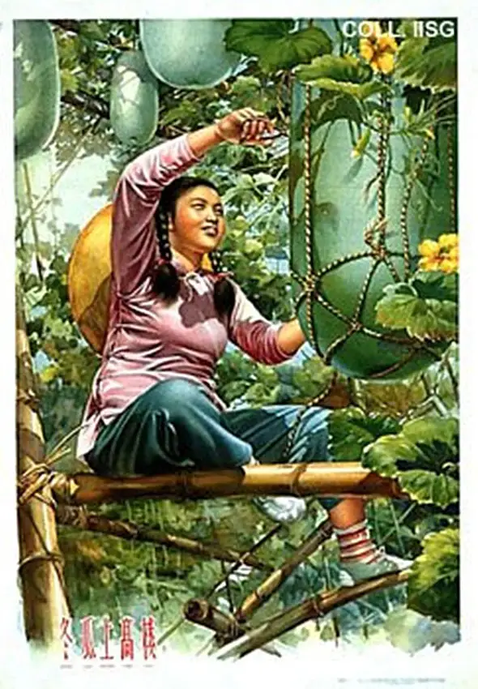

As we have seen, China was subject to huge changes in the twentieth century, experiencing several revolutions including in 1911, 1949 and 1966-76.

**Must do:**

1. **Watch:** documentary [This documentary on Mao Zedong](https://www.youtube.com/watch?v=ewXLOSEeyKA). Note down dates of key events in twentieth-century China.
2. **Read:** [article by Michael Lynch - Mao: Liberator or Oppressor?](https://drive.google.com/open?id=1WNlTLUETU7gECg_kO57m-Lonf_tEhHou)
3. **Create:** a timeline showing 10 key events that you identify as being important to twentieth-century China. You must include at least one event from before 1920, and at least one from after 1976.

You **should**:

* include a brief explanatory sentence about each event, and / or illustrate them with images or symbols
* think carefully about Lynch’s article and try to identify what arguments he puts forward about Mao Zedong. Is his portrayal negative, positive or a mixture?

You **could:**

* choose to present your work in a creative way - powerpoint presentation, podcast, video or Ted talk.
* use <https://alphahistory.com/chineserevolution/> to find out more about any events or people who you’ve found interesting.
* read [Frank Dikötter’s article on the Cultural Revolution.](https://drive.google.com/file/d/1mwfJz3N7G1UFFxnJ_X--DJJ8B6P16B7m/view?usp=sharing)

****************************************************

**IB History: Course information & FAQs**

|  | **% of final marks** | |
| --- | --- | --- |
| **SL** | **HL** |
| **Paper 1: Rights and Protest**  (*Four short-answer/structured questions based on sources – 60 minute exam*) | **30%** | **20%** |
| **Paper 2: Authoritarian states / The Cold War**  (*Two* *essays – one from each topic – 90 minute exam*) | **45%** | **25%** |
| **SL/HL internal assessment**  Historical investigation  *Coursework – structured research project (choice of topics)* | **25%** | **20%** |
| **Paper 3: History of Europe (HL only)**  Russia 1855 - 1924  Soviet and Post-Soviet Russia 1924-2000  The French Revolution & Napoleon 1774-1815  *(Three essays – 150 minute exam)* | - | **35%** |

1. **Do I need to buy a textbook?**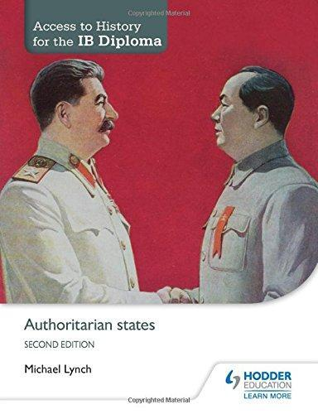

If you are able to, it would be helpful for you to buy a copy of *Access to History for the IB Diploma: Authoritarian States* (Second Edition) by Michael Lynch, Hodder Education 2015 (about £20.00).

1. **What equipment will I need for History lessons?**

You will need to bring a ring binder with dividers, some A4 lined paper, a pen, pencil and a highlighter. Coloured pens also come in handy!

1. **How much IB History homework will I get each week?**

About an hour and a half of ‘planned study’ each week. This could be research, preparing for a group discussion or presentation, writing an essay, or revising for a timed essay or quiz.

1. **What trips are planned?**

This year we took part in the New York & Washington trip with the Politics Department, & we ran a research & using sources workshop using the Mass Observation Archive at Sussex University’s ‘The Keep’. In recent years we have also been to Edinburgh & the National Gallery in London. We hope to offer similar opportunities in the future.

**IB History: course content**

**Paper 1: Higher and Standard level – Rights and Protest**

The struggles for rights and freedoms in the mid-20th century: two case studies which consider the nature and characteristics of discrimination, protests and action, and the role and significance of key individuals and groups.

* The civil rights movement in the US between 1954 and the passing of the Voting Rights Act in 1965.
* protests against apartheid in South Africa, focusing specifically on the years 1948–1964, beginning with the election of the National Party in 1948 and ending with the imprisonment of Nelson Mandela and his co-defendants following the Rivonia trial 1964.

**Paper 2: Higher and Standard Level - Themes in World History**

**Authoritarian States: Mao’s China & Perón’s Argentina**

* Emergence of authoritarian states - the conditions that facilitated the rise of authoritarian states in the 20th century, and the methods used by parties and leaders to take power
* Consolidation and maintenance of power – use of force, charismatic leadership, propaganda; treatment of opposition; impact of foreign policy
* Aims and results of domestic policies: economic, political, social and cultural; impact on women and minorities; extent of control

**The Cold War: superpower tensions and rivalries**

* Rivalry, mistrust and accord – emergence of superpower rivalry; ideology; fear and aggression; economic interests; comparison of roles of USA and USSR; relations between the USA, USSR and China 1947-79; reasons for the end of the Cold War
* Leaders and nations: impact of two leaders from different regions on the course of the Cold War; impact of Cold War tensions on two nations from different regions
* Cold War crises: detailed study of causes, impact and significance of two crises

**Paper 3: History of Europe (Higher Level only)**

**The French Revolution and Napoleon I**

This topic deals with the origins, outbreak, course and impact of the French Revolution. It focuses on the social, economic, political and intellectual challenges confronting the Ancien Régime and the stages of the revolutionary process during this period, culminating in the rise and rule of Napoleon Bonaparte. The section requires investigation of the impact of the French Revolution, as well as Napoleon’s domestic and foreign policies, upon France and its European neighbours.

**Imperial Russia, revolution, and the establishment of the Soviet Union 1853‑1924**

This topic explores change and continuity in Russia. You will compare modernization and conservatism in tsarist Russia - and the eventual collapse of the tsarist autocracy - with the creation of the USSR and the rule of Lenin. You will consider the extent of Alexander II’s reforms (1855–1881), and explore the policies of Alexander III (1881–1894) and Nicholas II (1894–1917): economic modernization, tsarist repression and the growth of opposition.

**The Soviet Union and post-Soviet Russia 1924-2000**

You will examine the rise and rule of Stalin, Khrushchev, Brezhnev and Gorbachev. Much of this topic will be studied during SL Cold War lessons, exploring East–West relations post-1945 in relation to Soviet aims and leadership. You will also investigate the causes of the decline and collapse of the Soviet Union, and finally political and economic developments under Yeltsin in post-Soviet Russia.

**Reading List**

Texts in blue: recommended purchase if possible – second-hand copies often available on Amazon or Abebooks

Texts in red: wider reading - pick one that looks interesting and dive in!

**IB Diploma textbooks:**

M. Lynch, ***Authoritarian States***, (Access to History for the IB Diploma, Hodder Education. Second edition, 2015)

Mark Rogers and Peter Clinton, ***Rights and Protest***, (Oxford IB Diploma Programme, Oxford University Press, 2015)

*Higher level only*: Mike Wells, ***History for the IB Diploma: Unification and Consolidation of Germany and Italy 1815-90***, (Cambridge, Second edition 2017)

**Authoritarian States: China under Mao Zedong**

Jung Chang, ***Wild Swans*** (Harper Collins 1991) excellent background and a gripping read: highly recommended

Jung Chang & Jon Halliday, ***Mao – The Unknown Story*** (Vintage, 2006)

Frank Dikotter on C20th dictators: <https://www.historyextra.com/period/20th-century/dictators-explained/>

Julia Lovell on Maoism: <https://www.historyextra.com/period/20th-century/maoism-who-was-mao-communist-leader-china-ideology-cundill-history-prize/>

Michael Lynch, ***The People’s Republic of China since 1949***, (Access to History – 2008).

G*ood A-level text if you want a bit more depth on a particular topic; useful for essays. Lots of copies in the college library.*

**Rights and Protest: 1948-64**

Nelson Mandela, ***The Long Walk to Freedom****,* (Abacus, 1995). Also the 2013 movie adaptation, available on Netflix.

Peter Hain, *Mandela:* ***His Essential Life***, (Rowman and Littlefield, 2018)

***Selma***. Directed by Ava DuVernay, (Paramount / Pathe, 2014). Available on Netflix.

**HL: Russia 1855 - 1924; 1924 - 2000:**

# [David Evans](http://www.amazon.co.uk/s/ref=ntt_athr_dp_sr_1?_encoding=UTF8&search-alias=books-uk&field-author=David%20Evans) & [Jane Jenkins](http://www.amazon.co.uk/s/ref=ntt_athr_dp_sr_2?_encoding=UTF8&search-alias=books-uk&field-author=Jane%20Jenkins), *Years of Russia and the USSR, 1851-1991* (Paperback) – lots of copies in the college library, good to dip into to supplement class notes when writing essays or revising

# Orlando Figes, *Revolutionary Russia 1891 – 1991: A Pelican Introduction* (2014)

# [Stephen J. Lee](http://www.amazon.co.uk/Stephen-J.-Lee/e/B001HMU13Q/ref=ntt_athr_dp_pel_1), *Russia and the USSR, 1855-1991: Autocracy and Dictatorship* (Questions and Analysis in History, 2005 – good for analysis of key themes)

# [Derrick Murphy](http://www.amazon.co.uk/Derrick-Murphy/e/B0034Q33UG/ref=ntt_athr_dp_pel_1), *Russia 1855-1964* (Flagship History, 2008)

Serhii Plohky, ***Chernobyl: History of a Tragedy****,* (Penguin, 2019)

# Dmitri Volkogonov, *Rise and Fall of the Soviet Empire: Political leaders from Lenin to Gorbachev* (Harper Collins 1998)

# Alexander Solzhenitsyn, *One Day in the Life of Ivan Denisovich*, (Penguin Modern Classics)