

Course Start

Course Start is independent learning you need to complete as a fundamental part of your introduction to the course. It should take you approximately 5 hours to complete.

| **Course Name** | IB Physics |
| --- | --- |
| How this **Course Start** fits into the first term of the course | There will be a test on this material in the first week. The course starts with Mechanics, Waves & Electricity.  This work revises GCSE material. |
| How will my **Course Start** learning be used in lessons? | Each topic will start from what you learned during your GCSE.  We will then extend your knowledge and problem-solving skills. |
| **Course Start** learning objectives | To revise:   * Basic maths * Atomic structure * Experimental techniques * Forces & motion * Electricity * Waves |
| Study Skills | * Organisation & time management * Mathematical techniques * Research * Problem solving * Communication using standard scientific conventions |

**Expectations for: Physics**

Our specification is: IB Diploma Physics HL & SL

| **What this course involves** |
| --- |
| Learning new ideas, concepts and techniques about Physics (see above) |
| Thinking & discussing new ideas & explanations in class |
| Taking & organising notes during lessons |
| Using mathematical techniques to solve problems |
| Completing ‘planned study’ (homework): topic workbooks |
| Regular ‘progress tests’ based on these workbooks |
| Developing independent learning skills, e.g., time management, preparing for lessons, completing tasks between lessons, etc. |
| Completing practical experiments and writing reports to gain the ‘Practical Endorsement’ |



**Course Start Work**

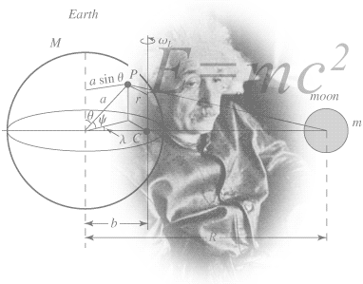

<http://scienceworld.wolfram.com/physics/images/main-physics.gif>

**Book Recommendations**

Below is a selection of books that should appeal to a physicist – someone with an enquiring mind who wants to understand the universe around us. None of the selections is a textbook full of equations, etc. (there will be plenty of time for that!) instead, each provides insight to either an application of physics or a new area of study that you will be meeting for the first time.

1. **Surely You're Joking Mr Feynman: Adventures of a Curious Character**

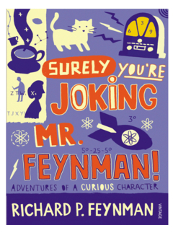

**ISBN - 009917331X -** Richard Feynman was a Nobel Prize winning Physicist. People often say that he epitomises what a Physicist is. By reading this book you will get insight into his life’s work including the creation of the first atomic bomb, his bongo playing adventures and his work in the field of particle physics.

(Also available on Audio book).

# Moondust: In Search of the Men Who Fell to Earth

# ISBN – 1408802384 - One of the greatest scientific achievements of all time was putting mankind on the surface of the moon. Only 12 men made the trip to the surface, at the time of writing the book only 9 were still alive. The book does an excellent job of using the personal accounts of the 9 remaining astronauts and many others involved in the space program at looking at the whole space-race era, with hopefully a new era of space flight about to begin as we push on to put mankind on Mars in the next couple of decades.

# Quantum Theory Cannot Hurt You: Understanding the Mind-Blowing Building Blocks of the Universe

# ISBN - 057131502X - Any Physics book by Marcus Chown is an excellent insight into some of the more exotic areas of Physics that requires no prior knowledge. In your first year of A-Level study you will meet the quantum world for the first time. This book will fill you with interesting facts and handy analogies to whip out to impress your peers!

# A Short History of Nearly Everything

# ISBN – 0552997048 - A modern classic. Popular science writing at its best. A Short History of Nearly Everything Bill Bryson’s quest to find out everything that has happened from the Big Bang to the rise of civilization - how we got from there, being nothing at all, to here, being us. Hopefully by reading it you will gain an awe-inspiring feeling of how everything in the universe is connected by some fundamental laws.

# Thing Explainer: Complicated Stuff in Simple Words

# ISBN – 1408802384 - This recommendation is a book of illustrated cartoon diagrams that should appeal to the scientific side of everyone. Written by the creator of online comic XTCD (a great source of science humour) is a book of blueprints from everyday objects such as a biro to the Saturn V rocket and an atom bomb, each one meticulously explained BUT only with the most common 1000 words in the English Language.

# 

# Sustainability Without the Hot Air

# Sustainable Energy - without the hot air

# A free book! With a 10-page synopsis underneath.

# https://www.withouthotair.com/

# <https://www.withouthotair.com/synopsis10.pdf>

# Movie / Video Clip Recommendations

# Hopefully you’ll get the opportunity to soak up some of the Sun’s rays over the summer – synthesising some important Vitamin-D – but if you do get a few rainy days where you’re stuck indoors here are some ideas for programmes to watch or clips to find online.

# Online Clips / Series

# Minute Physics – Hundreds of Physics questions explained simply (in felt tip) in a couple of minutes. Addictive viewing that will have you watching clip after clip – a particular favourite of mine is “Why is the Sky Dark at Night?”

# <https://www.youtube.com/user/minutephysics>

# Shock and Awe, The Story of Electricity – A 3 part BBC documentary that is essential viewing if you want to see how our lives have been transformed by the ideas of a few great scientists a little over 100 years ago. The link below takes you to a stream of all three parts joined together but it is best watched in hourly instalments.

# <https://www.youtube.com/watch?v=Gtp51eZkwoI>

# NASA TV – Online coverage of launches, missions, testing and the ISS. Plenty of clips and links to explore to find out more about applications of Physics in Space technology.

# <http://www.nasa.gov/multimedia/nasatv/>

# The Fantastic Mr. Feynman – I recommended the book earlier, I also cannot recommend this 1 hour documentary highly enough. See the life’s work of the “great explainer”, a fantastic mind that created mischief in all areas of modern Physics.

# <https://www.youtube.com/watch?v=H9fjhQMsDW4>

# Fun to Imagine– More gems from Feynman.

# <https://www.youtube.com/results?search_query=fun+to+imagine>

# Pale Blue Dot– As it says: one of the greatest speeches about humanity. Ever.

# <https://www.youtube.com/watch?v=EWPFmdAWRZ0&t=32s>

**Pre-Knowledge Topics**

Below are ten topics that are essential foundations for the course. Each topic has example questions and links where you can find our more information as you prepare for next year.

| **Prefix** | **Symbol** | **Power of ten** |
| --- | --- | --- |
| Pico | P | X 10-12 |
| Nano | n | x 10-9 |
| Micro | μ | x 10-6 |
| Milli | m | x 10-3 |
| Kilo | k | x 103 |
| Mega | M | x 106 |
| Giga | G | x 109 |
| Tera | T | X 1012 |

**Symbols and Prefixes**

At A level, unlike GCSE, you need to remember all symbols, units and prefixes. Below is a list of quantities you may have already come across and will be using during your A level course

| **Quantity** | **Symbol** | **Unit** |
| --- | --- | --- |
| Velocity | v | ms-1 |
| Acceleration | a | ms-2 |
| Time | t | S |
| Force | F | N |
| Resistance | R | Ω |
| Potential difference | V | V |
| Current | I | A |
| Energy | E or W | J |
| Pressure | P | Pa |
| Momentum | p | kgms-1 |
| Power | P | W |
| Density | *ρ* | kgm-3 |
| Charge | Q | C |

Solve the following:

1. How many metres in 2.4 km?
2. How many joules in 8.1 MJ?
3. Convert 326 GW into W.
4. Convert 54 600 mm into m.
5. How many grams in 240 kg?
6. Convert 0.18 nm into m.
7. Convert 632 nm into m. Express in standard form.
8. Convert 1002 mV into V. Express in standard form.
9. How many eV in 0.511 MeV? Express in standard form.
10. How many m in 11 km? Express in standard form.

**Standard Form**

At A level quantities will be written in standard form, and it is expected that your answers will be too.

This means answers should be written as ….x 10y, e.g., for an answer of 1200kg we would write 1.2 x 103 kg.

1. Write 2530 in standard form.
2. Write 280 in standard form.
3. Write 0.77 in standard form.
4. Write 0.0091 in standard form.
5. Write 1 872 000 in standard form.
6. Write 12.2 in standard form.
7. Write 2.4 x 102 as a normal number.
8. Write 3.505 x 101 as a normal number.
9. Write 8.31 x 106 as a normal number.
10. Write 6.002 x 102 as a normal number.
11. Write 1.5 x 10-4 as a normal number.
12. Write 4.3 x 103 as a normal number.

**Rearranging formulae**

This is something you will have done at GCSE and it is crucial you master it for success at A level. For a recap of GCSE watch the following links:

[www.khanacademy.org/math/algebra/one-variable-linear-equations/old-school-equations/v/solving-for-a-variable](http://www.khanacademy.org/math/algebra/one-variable-linear-equations/old-school-equations/v/solving-for-a-variable)

[www.youtube.com/watch?v=_WWgc3ABSj4](http://www.youtube.com/watch?v=_WWgc3ABSj4)

Rearrange the following:

1. E=m x g x h to find h
2. Q= I x t to find I
3. E = ½ m v2 to find m
4. E = ½ m v2 to find v
5. v = u + at to find u
6. v = u + at to find a
7. v2 = u2 +2as to find s
8. v2 = u2 +2as to find u

**Significant figures**

At A level you will be expected to use an appropriate number of significant figures in your answers. The number of significant figures you should use is the same as the number of significant figures in the data you are given. You can never be more precise than the data you are given so if that is given to 3 significant your answer should be too, e.g.,

Distance = 8.24m, time = 1.23s therefore speed = 6.75ms-1

The website below summarises the rules and how to round correctly.

<http://www.purplemath.com/modules/rounding2.htm>

Give the following to 3 significant figures:

1. 3.4527
2. 40.691
3. 0.838991
4. 1.0247
5. 59.972

Calculate the following to a suitable number of significant figures:

1. 63.2/78.1
2. 39+78+120
3. (3.4+3.7+3.2)/3
4. 0.0256 x 0.129
5. 592.3/0.1772

**Atomic Structure**

You will study nuclear decay in more detail at A level covering the topics of radioactivity and particle physics. In order to explain what happens you need to have a good understanding of the model of the atom. You need to know of what the atom is made; relative charges and masses and how sub-atomic particles are arranged.

The following video explains how the current model was discovered [www.youtube.com/watch?v=wzALbzTdnc8](http://www.youtube.com/watch?v=wzALbzTdnc8)

Describe the model used for the structure of an atom including details of the individual particles that make up an atom and the relative charges and masses of these particles. You may wish to include a diagram and explain how this model was discovered by Rutherford

**Recording Data**

Whilst carrying out a practical activity you need to write all your raw results into a table *as you measure them*. Don’t wait until the end, discard anomalies and then write it up in neat.

Tables should have column heading and units in this format quantity/unit e.g., length / mm

All results in a column should have the same precision and if you have repeated the experiment, you should calculate a mean to the same precision as the data.

Below is a table of results from an experiment where a ball was rolled down a ramp of different lengths. A ruler and stopwatch were used.

**1)** Identify the errors the student has made.

|  | **Time** | | | |
| --- | --- | --- | --- | --- |
| **Length/(cm)** | **Trial 1** | **Trial 2** | **Trial 3** | **Mean** |
| 10 | 1.45 s | 1.48 | 1.46 | 1.463 |
| 22 | 2.78 s | 2.72 | 2.74 | 2.747 |
| 30 | 4.05 s | 4.01 | 4.03 | 4.03 |
| 41 | 5.46 s | 5.47 | 5.46 | 5.463 |
| 51 | 7.02 s | 6.96 | 6.98 | 6.98 |
| 65 | 8.24 s | 9.68 | 8.24 | 8.72 |
| 70 | 9.01 s | 9.0 | 9 | 9.01 |

**Graphs**

After processing your data, the next step is to draw a graph that will be useful to you. Drawing a graph is a skill you should be familiar with already, but you need to be extremely vigilant at A level. Before you draw your graph to need to identify a suitable scale to draw taking the following into consideration:

* the maximum and minimum values of each variable
* whether 0.0 should be included as a data point; graphs don’t always need to show the origin, a false origin can be used if your data doesn’t start near zero.
* the plots should cover at least half of the grid supplied for the graph.
* the axes should use a sensible scale, e.g., multiples of 1,2, 5 etc.

Identify how the following graphs could be improved

**Graph 1 Graph 2**

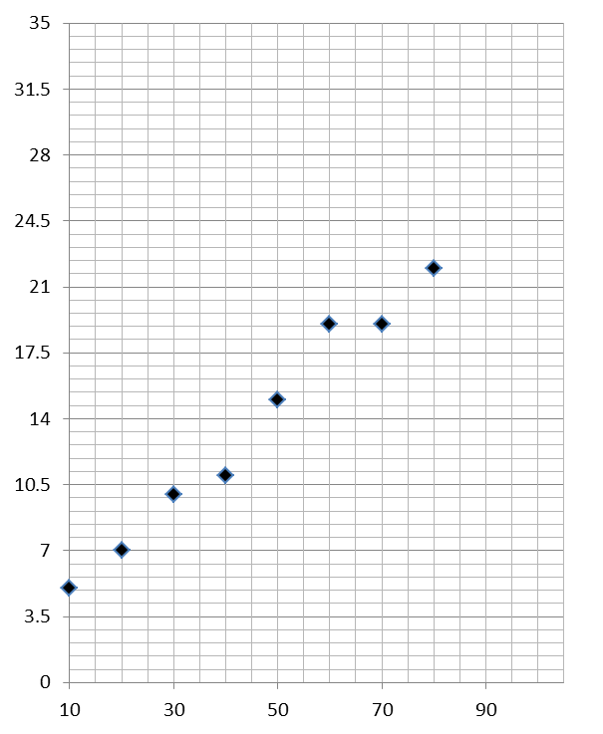

**Forces and Motion**

At GCSE you studied forces and motion and at A level you will explore this topic in more detail so it is essential you have a good understanding of the content covered at GCSE. You will be expected to describe, explain and carry calculations concerning the motion of objects. The websites below cover Newton’s laws of motion and have links to these in action.

<http://www.physicsclassroom.com/Physics-Tutorial/Newton-s-Laws>

Sketch a velocity-time graph showing the journey of a skydiver after leaving the plane to reaching the ground.

Mark on terminal velocity.

**Electricity**

At A level you will learn more about how current and voltage behave in different circuits containing different components. You should be familiar with current and voltage rules in a series and parallel circuit as well as calculating the resistance of a device.

<http://www.allaboutcircuits.com/textbook/direct-current/chpt-1/electric-circuits/>

<http://www.physicsclassroom.com/class/circuits>

**1a)** Add the missing ammeter readings on the circuits below. 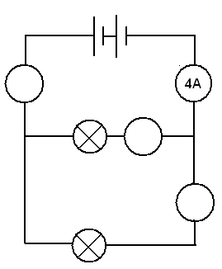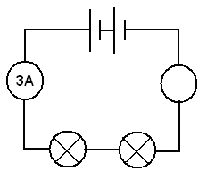

**b)** Explain why the second circuit has more current flowing than the first.

**2)** Add the missing potential differences to the following circuits

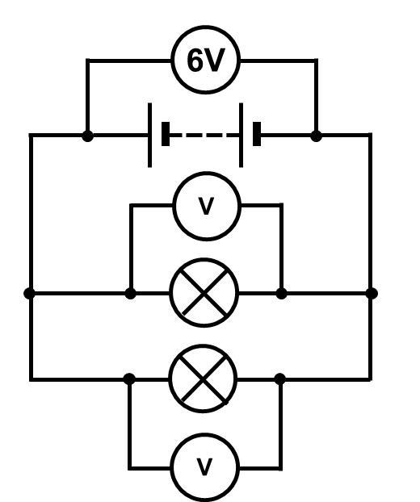

**Waves**

You have studied different types of waves and used the wave equation to calculate speed, frequency and wavelength. You will also have studied reflection and refraction.

Use the following links to review this topic.

<https://www.khanacademy.org/science/physics/mechanical-waves-and-sound/mechanical-waves/v/introduction-to-waves>

**1)** Draw a diagram showing the refraction of a wave through a rectangular glass block. Explain why the ray of light takes this path.

**2)** Describe the difference between a longitudinal and a transverse wave and give an example of each

**3)** Draw a wave and label the wavelength and amplitude

**Pre-Knowledge Topics Answers:**

**Symbols and prefixes**

1. 2400
2. 8 100 000
3. 326 000 000 000
4. 54.6
5. 240 000
6. 1.8 x 10-8
7. 6.32 x 10-7
8. 1.002
9. 5.11 x 10-5
10. 1.1 x 104

**Standard Form:**

1. 2.53
2. 2.8
3. 7.7
4. 9.1
5. 1.872
6. 1.22
7. 2400
8. 35.05
9. 8 310 000
10. 600.2
11. 0.00015
12. 4300

**Rearranging formulae**

1. h= E/ (m x g)
2. I = Q/t
3. m = (2 x E)/v2 or E/(0.5 x v2)
4. v= √((2 x E )/m)
5. u = v – at
6. a = (v-u)/t
7. s = (v2 – u2) / 2a
8. u = √(v2-2as)

**Significant figures**

1. 3.35
2. 40.7
3. 0.839
4. 1.02
5. 60.0
6. 0.809
7. 237
8. 3.4
9. 0.00330
10. 3343

**Atomic Structure**

contains protons, neutrons and electrons

**Relative charge:**

protons are positive (+1)

electrons are negative (-1)

neutrons are uncharged (0)

**Relative mass:**

proton 1

neutron 1

electron (about) 1/2000

protons and neutrons make up the nucleus

the nucleus is positively charged

electrons orbit the nucleus at a relatively large distance from the nucleus

most of the atom is empty space

nucleus occupies a very small fraction of the volume of the atom

most of the mass of the atom is contained in the nucleus

total number of protons in the nucleus equals the total number of electrons orbiting it in an atom

**Recording data**

(cm) should not be in brackets

Time should have a unit next to it

The times in the first column should not have a unit in the table

Length can be measured to the nearest mm so should be 10.0, 22.0 etc

Length 65 trial 2 is an anomaly and should have been excluded from the mean

All mean values should be to 2 decimal places

Mean of length 61 should be 6.99 (rounding error)

**Graphs**

**Graph 1:**

Axis need labels

Point should be x not dots

Line of best fit is needed

y axis is a difficult scale

x axis could have begun at zero so the y-intercept could be found

**Graph 2:**

y-axis needs a unit

curve of best fit needed not a straight line

Point should be x not dots

**Forces and motion**

Graph to show acceleration up to a constant speed (labelled terminal velocity). Rate of acceleration should be decreasing. Then a large decrease in velocity over a short period of time (parachute opens), then a decreasing rate of deceleration to a constant speed (labelled terminal velocity)

**Electricity**

1a) Series: 3A, Parallel top to bottom: 4A,2A,2A

b) Less resistance in the parallel circuit. Link to R=V/I. Less resistance means higher current.

2) Series: 3V, 3V, Parallel: 6V 6V

**Waves**

1) When light enters a more optically dense material it slows down and therefore bends towards the normal. The opposite happened when it leaves an optically dense material.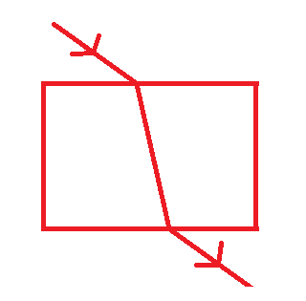

2) A longitudinal wave oscillates parallel to the direction of energy transfer (e.g. sound). A transverse wave oscillates perpendicular to the direction of energy transfer (e.g. light)

3) 

