Welcome to A Level PE: Course Start

Course Start is a range of independent learning tasks that you need to complete as a fundamental part of your introduction to the course. It should take you approximately **5 hours to complete.** You will submit this work to your tutors in your first week of lessons and the work you produce will be used to help you make a smooth transition from School to College. Good luck with the tasks!

| How this **Course Start** fits into the first term of the course | Welcome to **A Level PE.** The purpose of this activity is to Introduce you to both the **theoretical element** of the A Level PE course and also get you thinking about your **practical EAPI** assessment. This is a verbal assessment, where you need to evaluate the strengths and weaknesses of a performance in your chosen sport. |
| --- | --- |

| How will my **Course Start** learning be used in lessons? | Once teaching starts, you will begin learning about the skeletal and muscular systems and apply this to your own sporting performance. This is a key element of the Anatomy & Physiology aspect of the course & helps you get a headstart in your A&P lessons from the off!  You’ll also begin to understand how sports performers acquire & learn new skills through the Acquisition of Skill Unit. The first part of the specification looks at what a skilled performance looks like & how performers learn and apply skills.  Finally, your EAPI requires you to evaluate sporting performance in your chosen sport. To begin thinking about this as early as September will help you to critically evaluate performance using all of the knowledge you have in your chosen sport. |
| --- | --- |

| **Course Start** learning objectives | * To understand how the skeletal & muscular systems aid movement in sporting performance. * Develop an understanding of how performers acquire new skills through a practical task, such as juggling. * To consider the strengths and weaknesses of skills, tactics & fitness in your chosen sport. |
| --- | --- |

| What are the **expectations** in A Level PE and what does the course involve? | A Level PE is a fantastic opportunity for you to learn about key theoretical elements relating to sport and apply it to your own sporting performance.   * You will be expected to complete the pre learning tasks before all lessons. This is really important for stretching your knowledge further in class and allows for more practical based tasks. * You will have regular progress checks at the end of each week - This will be marked & tracked. * Setting of weekly HW by answering long mark questions (10 markers / 20 markers). * A commitment & dedication towards your NEA (Non Exam Assessment) activities - A lot of this will be carried out *i*ndependently |
| --- | --- |

**Course start: A level PE:**

You are expected to complete **ALL tasks** in this course start pack. You can either print out the pack and complete it by hand or preferably, make a copy of this pack and type in your answers ready to submit when you arrive in September.

**Task One: Your Sporting Life for your chosen sport.**

For us to understand your sporting profile better, produce a max 300 word account of your sporting journey up until this point and how you aim to improve over the next 2 years..

| **Sporting Profile:***You could include; Playing position, length of time playing, how often you perform & train, clubs / school / county / regional representation, Major achievements & Awards, future goals and plans and how you will action your performance goals over the next 2 years. Remember, your ability to perform to a high standard is 15% of your overall grade.* |
| --- |

**Task Two: Applying sporting knowledge to your sport.**

Alongside your practical performance (15%), a further 15% of your final grade is based on your **EAPI (Evaluation and Analysis of Performance for Improvement).** You must analyse a performer's strengths and weaknesses, produce a development plan and apply your knowledge of Physiology, Social Concepts and Psychological elements of the A Level course to justify your choices. This is a spoken (verbal) assessment which is filmed as evidence.

In order to do this successfully, we’d like you to identify 4 key skills, tactics & fitness components that are needed in order to be successful in your sport - Explain how & why they are carried out and what is the intended end result / outcome.

| **Skills** | **Explanation - Phases, technique, coaching points, perfect model** | **Why? What’s the desired outcome** |
| --- | --- | --- |
|  |  |  |
|  |  |  |
|  |  |  |
|  |  |  |

| **Tactics** | **Explanation - Type - Defence/attack, Individual or Team - How?** | **Why? What’s the desired outcome** |
| --- | --- | --- |
|  |  |  |
|  |  |  |
|  |  |  |
|  |  |  |

| **Fitness Components** | **Explanation - Definition, why it’s needed, how it helps perform skill** | **How it benefits the athlete / team?** |
| --- | --- | --- |
|  |  |  |
|  |  |  |
|  |  |  |
|  |  |  |

**Task Three: Evaluation and Analysis of a performance that you have observed,**

**MUST WATCH: This video gives an excellent overview of what to expect for your EAPI and what you need to do to succeed.** [OCR A-Level Linear PE EAPI - Introducing the EAPI](https://www.youtube.com/watch?v=kmH6x9uEXUA&list=PLEqC3mY6IKxOCf5DUBo-7DuaZYoEQ_gJK)

**Video Resources** - Below is a resource bank of sporting videos, we’d like you to:

* Select ONE video for your chosen sport (if there is not one below, please find footage on youtube).
* Watch 15 minutes of the performance from the You Tube Clips - This must be the same performer throughout the video
* Using the templates provided below, make notes using the note sheet and consider the performers **strengths** and **weaknesses** in relation to their:
* Skills - 3 strengths & 3 weaknesses
* Tactics - 3 strengths & 3 weaknesses
* Fitness components - 3 strengths & 3 weaknesses

Make sure you apply any THEORY from what you already know about the theory side of PE & Sport - You could consider, bones, muscles, joints, psychology, sociology to this,

**Performance Video Resource Bank:**

**Badminton:** [GCSE Sports Studies 2018 - Arran Gallagher (7) badminton footage](https://www.youtube.com/watch?v=rUddokCyXkc)

**Rugby:** [LIVE RUGBY: HURSTPIERPOINT COLLEGE VS UPPINGHAM 10/10/19](https://www.youtube.com/watch?v=my-VUKJbU-w)

**Hockey:** [Rhys A level Hockey Video](https://www.youtube.com/watch?v=Z-nfxaW5_GI)

**Tennis:** [Amateur Tennis - S. v Steve T _01062012.MP4](https://www.youtube.com/watch?v=IKvp4rCjha0&list=PLLqoGA1ZdFvb77TULy1ywNwspEpxcuDYq&index=25)

**Basketball:** [A-Level PE T-Block Performance Analysis](https://www.youtube.com/watch?v=YmAeCAeSBuc)

**Football:** [Oxford vs Cambridge, 131st Varsity Football Match 2015](https://www.youtube.com/watch?v=8DT7z6W4Cfk&list=PLLqoGA1ZdFvb77TULy1ywNwspEpxcuDYq&index=18)

**Cricket:** [Liverpool Cricket Club Vs St Helens Cricket Club (11.07.15)](https://www.youtube.com/watch?v=cV3toaWnIQw&list=PLLqoGA1ZdFvb77TULy1ywNwspEpxcuDYq&index=11)

**Boxing:** [# 13 Amature boxing at Champions Boxing Academy June 2 ,2018](https://www.youtube.com/watch?v=GUgjtphHKy4)

**Swimming:** <https://www.youtube.com/watch?v=5UHPZ3tiG5k>

**Range of Sports:** [EAPI Videos - YouTube](https://www.youtube.com/playlist?list=PLLqoGA1ZdFvb77TULy1ywNwspEpxcuDYq)

**OCR EAPI (H155/H555) Candidate notes sheet Strengths**

| **Assessment**  **criteria** | **Evaluation of performance** | | **Application of theory** |
| --- | --- | --- | --- |
| **Observations (explain why)** | **Overall success of**  **performance** | **Physiological, psychological and socio-cultural factors** |
| **STRENGTH of Skills** |  |  |  |
| **STRENGTH of Tactics/**  **compositional**  **ideas** |  |  |  |
| **STRENGTH of Fitness** |  |  |  |

**OCR EAPI (H155/H555) Candidate notes sheet Weaknesses**

| **Assessment**  **criteria** | **Evaluation of performance** | | **Application of theory** |
| --- | --- | --- | --- |
| **Observations (explain why)** | **Overall success of**  **performance** | **Physiological, psychological and socio-cultural factors** |
| **WEAKNESSES of Skills** |  |  |  |
| **WEAKNESSES of Tactics/**  **compositional**  **ideas** |  |  |  |
| **WEAKNESSES of Fitness** |  |  |  |

**ACQUISITION OF SKILL - LEARNING NEW SKILLS!**

**Task Four:** A FUN & Practical task. Here we would like you to **LEARN A NEW MOTOR SKILL** & reflect on your learning and performance throughout.

**The Juggle Challenge** - We would like you to attempt to juggle and reflect on your learning and improvement over time. It is said that in order to become an elite performer you need to carry out (in the region of) 10’000 hours practice to become world class!

**MUST WATCH: JUGGLE TUTORIAL** [How to Juggle Three Balls](https://www.youtube.com/watch?v=kCt1bmSASCI&t=30s)

Watch the video & attempt to teach yourself to juggle with 3 balls - You can use tennis balls, juggling balls, bean bags, or even rolled up socks. Spend 30 minutes over 5 separate sessions and reflect on your skills and learning.

**APPLY IT to theory** - We would like you to watch this video [Three stages of learning movement](https://www.youtube.com/watch?v=OHGE68ZS8g4) and identify what **stage of learning** you were at for each session and explain why - What characteristics did you display? Was there any improvement? Why not? What was your psychology like? Did you give up too easily?

| **Example** | **Reflection Session One** | **Reflection Session Two** | **Reflection Session Three** | **Reflection Session Four** | **Reflection Session Five** |
| --- | --- | --- | --- | --- | --- |
| *Eg, in my first session I made a lot of basic mistakes, I had to keep going back over step one to get a feel for the skill, I was clunky and unco-ordinated - I became Very frustrated with my performance - I’m still at the cognitive stage of learning.* |  |  |  |  |  |

**TASK:** Reflect on your juggle challenge and **CRITICALLY EVALUATE** the following statement (300 words max). ***World Class sport performers get to the very top of their sport because they are BORN talented and not MADE through hard work & practice****. Remember to weigh up both sides of the argument.*

|  | | |
| --- | --- | --- |
|

**Anatomy & Physiology - Bones, Joints & Movement analysis**

**Skeletal System**

Use the video to answer the following questions and worksheets: [The Skeletal System | Sport Science Hub: Physiology Fundamentals | Music Version](https://www.youtube.com/watch?v=m_tsmZ2dL_Q)

1. Draw arrows to Identify the names of the major bones of the skeleton in the image of the runner below
2. In each box describe which bones are meeting at each joint?

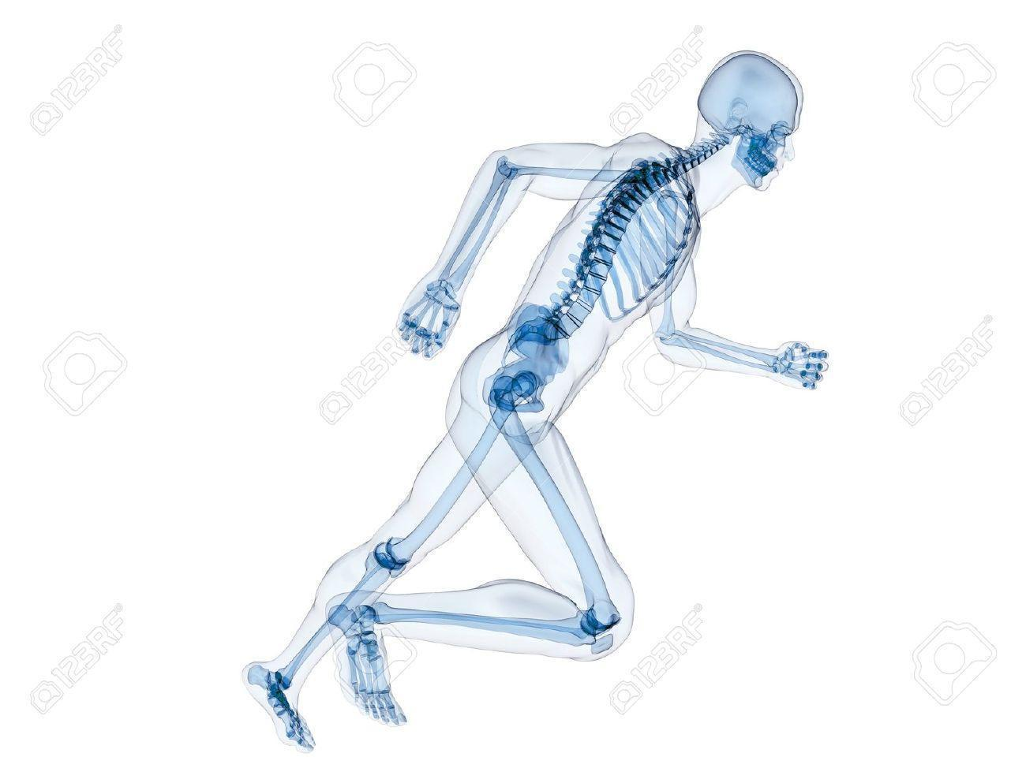











**ANALYSIS OF THE SKELETAL & MUSCULAR SYSTEMS - HOW THEY PRODUCE MOVEMENT IN SPORT AND EXERCISE**

Pick a sporting movement of your choice & use this worksheet to help you answer the Q’s: <https://docs.google.com/document/d/1wTpTQ3vfHQtHLv6Ka7kkkRoafAXp31DoJ8xs921RzNs/edit?usp=sharing>

1. Find pictures / draw a diagram to show the **preparation** and **execution** phases of movement from different planes of motion
2. Complete the second table for each of the major joints working during the action.
3. Explain this in your own words in writing underneath.

| PREPARATION | EXECUTION |
| --- | --- |
|  |  |

| Joint | Type of joint | Articulating bones | Movement | Muscle roles; (agonist/antagonist - synergist/fixator) | Muscle contraction types |
| --- | --- | --- | --- | --- | --- |
| Knee |  |  |  |  |  |
| Elbow |  |  |  |  |  |
| Shoulder |  |  |  |  |  |