Welcome to BTEC Sport (Ext. Cert & Diploma): Course Start

Course Start is independent learning you need to complete as a fundamental part of your introduction to the course. It should take you approximately 5 hours to complete.

| How this **Course Start** fits into the first term of the course | Our Course Start looks directly at the Anatomy & Physiology work that students will study as soon as they begin, leading up to the January exam. |
| --- | --- |

| How will my **Course Start** learning be used in lessons? | Course Start will be used for students when opening their skeletal and muscular system topics. It will also be used later in the year when the student starts their coursework topics of Professional Development & Practical Sport. |
| --- | --- |

| **Course Start** learning objectives | * Demonstrate knowledge of body systems, structures, functions, characteristics, definitions and other additional factors affecting each body system * Examine the skills, techniques and tactics required to perform in selected sports * Understand the career and job opportunities in the sports industry |
| --- | --- |

| What are the **expectations** in A Level PE and what does the course involve? | Our specification is: [BTEC Level 3 Sport](https://qualifications.pearson.com/content/dam/pdf/BTEC-Nationals/Sport/20161/specification-and-sample-assessments/btec-l3-national-ext-cert-in-sport-spec.pdf)  This course involves:   * Completing two external exams for Anatomy & Physiology and Fitness Training & Programming. * Taking part in regular enrichment activities. * Taking part in fitness tests and training ready for use in assignment work. |
| --- | --- |

**BTEC Sport**

**-----------------------------------------------------------------------**

**COURSE START WORK 2024**

Hello again, this is your Course Start task to be completed before your first lesson in college. This is an extension of the year 11 preparation work that you hopefully completed over the summer.

On the following pages you will find the worksheet to complete -

1. ‘**Sports Performance** - Skills and Techniques - What, How and Why…’
2. ‘**Anatomy & Physiology** - Bones, Joints & Movement Analysis’
3. ‘**Professional Development** - Career Research’

The performance of sport itself is central to any sports programme, it is therefore essential we examine this in great detail and continue to build our understanding of performance as we progress through the different topics on your course.

This work will contribute towards your **Practical Performance** (Unit 7), **Anatomy & Physiology** (Unit 1 & 2) and **Professional Development** (Unit 3).

We look forward to seeing you all soon.

The PE & Sport Team

**Sports Performance - Skills and Techniques - What, How and Why...**

You are required to **select a sport** that you currently play or are interested in.

You then need to complete the table on the following page to **examine the main skills performed** in this sport.

* For each skill you should present the techniques employed or coaching points followed to perform effectively - how you do it.
* You should then discuss why it is performed this way, how does it affect the outcome or success of the skill.
* You may wish to take this further to consider different techniques or approaches that can be used for a given skill and provide examples from elite sport.

*Recommended Resources;*

*National governing body websites - coaching cards / PE teaching resources - websites - teachpe.com, ukcoaching.org, etc*

**Sports Performance - Skills and Techniques - What, How and Why...**

| **SPORT** |  | | | |
| --- | --- | --- | --- | --- |
| **SKILLS** | **Coaching Points / Technique;**  **How is it performed?** | **Why is it performed this way?**  **What is the aim & effect?** | **Alternative techniques ?** | **Picture / Images** |
| 1 |  |  |  |  |
| 2 |  |  |  |  |
| 3 |  |  |  |  |

**Anatomy & Physiology - Bones, Joints & Movement analysis**

**Skeletal System**

Use the video to answer the following questions and worksheets: [The Skeletal System | Sport Science Hub: Physiology Fundamentals | Music Version](https://www.youtube.com/watch?v=m_tsmZ2dL_Q)

1. Draw arrows to Identify the names of the major bones of the skeleton in the image of the runner below
2. In each box describe which bones are meeting at each joint?





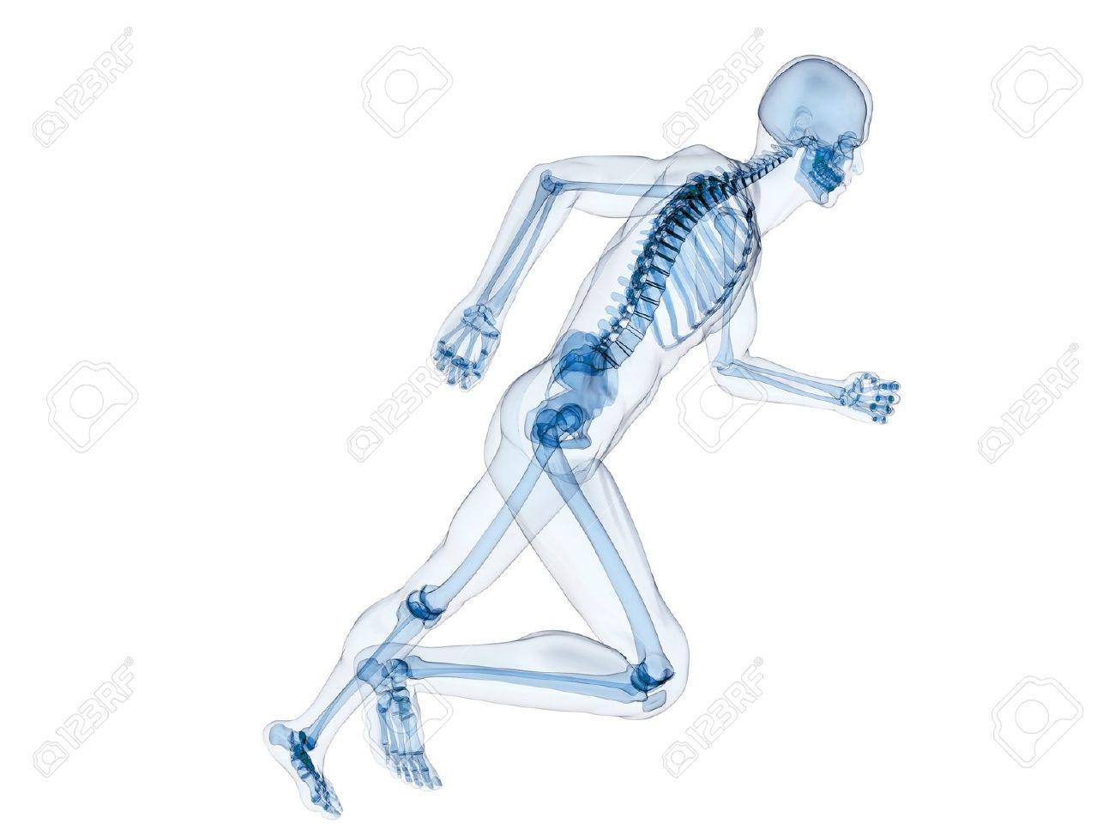







**ANALYSIS OF THE SKELETAL & MUSCULAR SYSTEMS - HOW THEY PRODUCE MOVEMENT IN SPORT AND EXERCISE**

Pick a sporting movement of your choice & use this worksheet to help you answer the Q’s: [Copy of Human Movement Patterns - Task Sheet](https://docs.google.com/document/d/1wTpTQ3vfHQtHLv6Ka7kkkRoafAXp31DoJ8xs921RzNs/edit?usp=sharing)

1. Find pictures / draw a diagram to show the **preparation** and **execution** phases of movement from different planes of motion
2. Complete the second table for each of the major joints working during the action.
3. Explain this in your own words in writing underneath.

| PREPARATION | EXECUTION |
| --- | --- |
|  |  |

| Joint | Type of joint | Articulating bones | Movement | Plane of movement | Muscle roles; (agonist/antagonist - synergist/fixator) | Muscle contraction types |
| --- | --- | --- | --- | --- | --- | --- |
| Knee |  |  |  |  |  |  |
| Elbow |  |  |  |  |  |  |
| Shoulder |  |  |  |  |  |  |

**Professional Development - Career Research**

| **Career research within the sport sector** - use the internet to help you find jobs that are currently available with the sector | | |
| --- | --- | --- |
| **Jobs that are currently available.** Please add links to the jobs, after you have given a brief about them. | | **Job selection.** Pick ONE of the jobs that you have just researched. Select one that you feel suits you and your interests. |
|  | |  |
| **What knowledge, skills and qualities are essential for you to be able to succeed in this role?** | | |
|  | | |